# 

### Semester One Examination, 2017

### Question/Answer booklet

# MATHEMATICS

**METHODS**

**UNIT 1**

## Section Two:

## Calculator-assumed

Your name

Teacher’s name

## Time allowed for this section

Reading time before commencing work: ten minutes

Working time: one hundred minutes

## Materials required/recommended for this section

***To be provided by the supervisor***

This Question/Answer booklet

Formula sheet (retained from Section One)

***To be provided by the candidate***

Standard items: pens (blue/black preferred), pencils (including coloured), sharpener, correction fluid/tape, eraser, ruler, highlighters

Special items: drawing instruments, templates, notes on two unfolded sheets of A4 paper, and up to three calculators approved for use in this examination

## Important note to candidates

No other items may be taken into the examination room. It is **your** responsibility to ensure that you do not have any unauthorised material. If you have any unauthorised material with you, hand it to the supervisor **before** reading any further.

## Structure of this paper

|  |  |  |  |  |  |
| --- | --- | --- | --- | --- | --- |
| Section | Number of questions available | Number of questions to be answered | Working  time (minutes) | Marks available | Percentage of examination |
| Section One:  Calculator-free | 7 | 7 | 50 | 52 | 35 |
| Section Two:  Calculator-assumed | 11 | 11 | 100 | 85 | 65 |
|  | | |  | **Total** | 100 |

## Instructions to candidates

1. The rules for the conduct of examinations are detailed in the school handbook. Sitting this examination implies that you agree to abide by these rules.

2. Write your answers in this Question/Answer booklet.

3. You must be careful to confine your response to the specific question asked and to follow any instructions that are specified to a particular question.

4. Additional working space pages at the end of this Question/Answer booklet are for planning or continuing an answer. If you use these pages, indicate at the original answer, the page number it is planned/continued on and write the question number being planned/continued on the additional working space page.

5. Show all your working clearly. Your working should be in sufficient detail to allow your answers to be checked readily and for marks to be awarded for reasoning. Incorrect answers given without supporting reasoning cannot be allocated any marks. For any question or part question worth more than two marks, valid working or justification is required to receive full marks. If you repeat any question, ensure that you cancel the answer you do not wish to have marked.

6. It is recommended that you do not use pencil, except in diagrams.

7. The Formula sheet is not to be handed in with your Question/Answer booklet.

Section Two: Calculator-assumed 65% (85 Marks)

This section has**eleven (****11)** questions. Answer **all** questions. Write your answers in the spaces provided.

Working time: 100 minutes.

Question 8 (6 marks)

(a) The variables $C$ and $n$ are directly proportional to each other, so that when $n=10$, it is known that $C=25$. Sketch a graph of the relationship between $C$ and $n$ on the axes below. (3 marks)

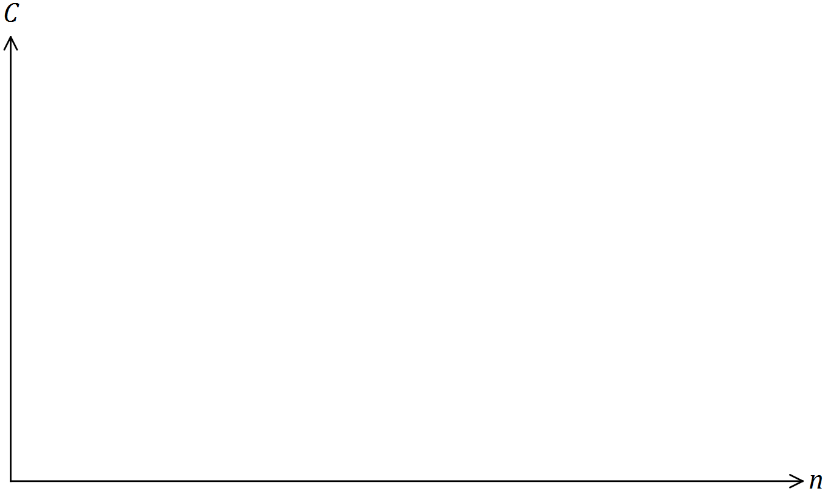

(b) The variables $A$ and $n$ are inversely proportional to each other, so that when $n=10$, it is known that $A=60$.

(i) Write an equation that relates $A$ and $n$. (2 marks)

(ii) Determine the value of $n$ when $A=15$. (1 mark)

**Question 9 (5 marks)**

**(a)** The volume (V) in litres (L) of a gas, at a fixed temperature and of a certain mass, varies inversely to the pressure (P) in Pascals (Pa).

(i) Find *k*, the constant of proportionality, given that when P = 11.5 Pa and V = 2.84 L.

(2 marks)

(ii) Describe the effect on V when P is halved. (1 mark)

**(b)** Jan is a real estate agent who earns a commission of 3.25% on the sale of a house. If $c is the commission and $s is the sale price of a house, show clearly c is directly proportional to s. (2 marks)

**Question 10 (5 marks)**

The reciprocal function 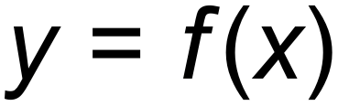 shown below has asymptotes at 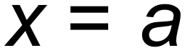 and 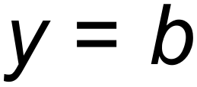.

The *y*-intercept is at (0, *c*).

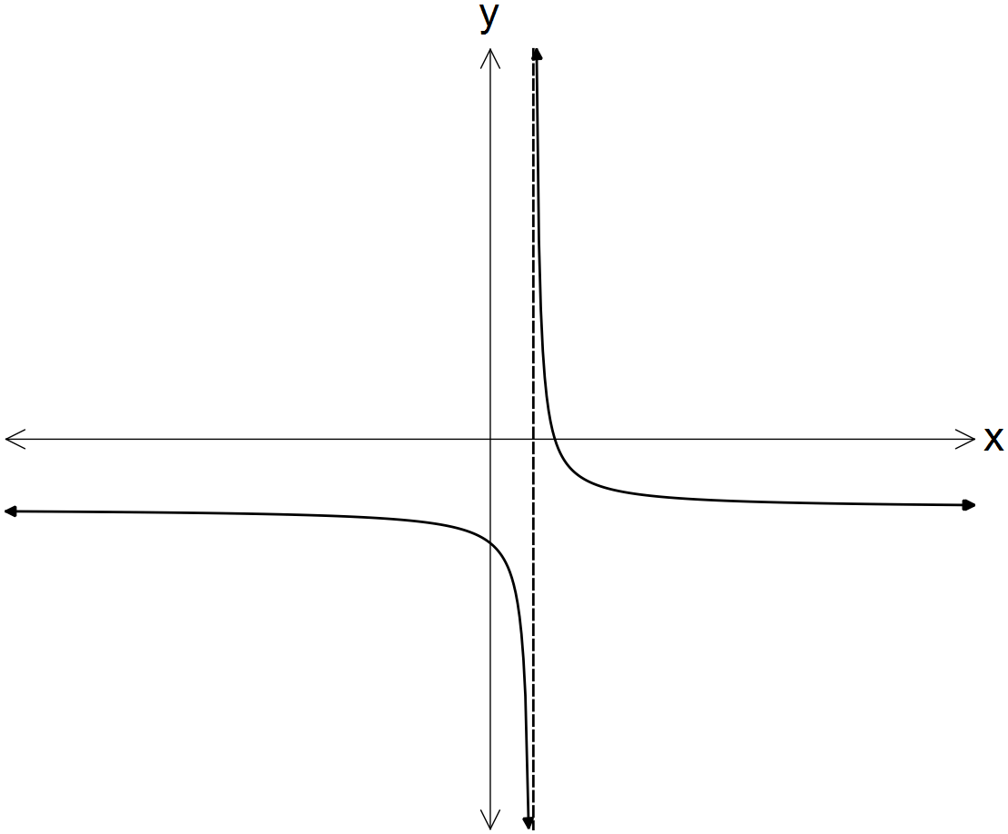

In terms of *a, b* and/or *c*:

**(a)** determine the equation of the horizontal asymptote for 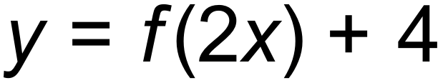. (1 mark)

**(b)** determine the coordinates of the *y*-intercept of 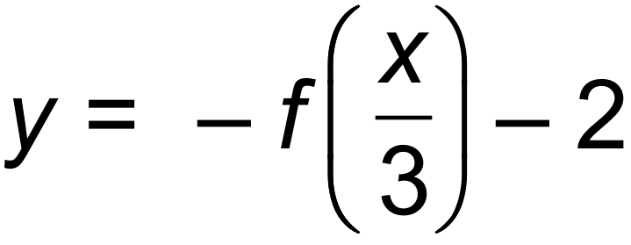. (2 marks)

**(c)** state the domain of the function 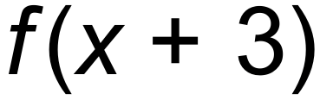. (2 marks)

**Question 11 (11 marks)**

Consider the functions graphed below.

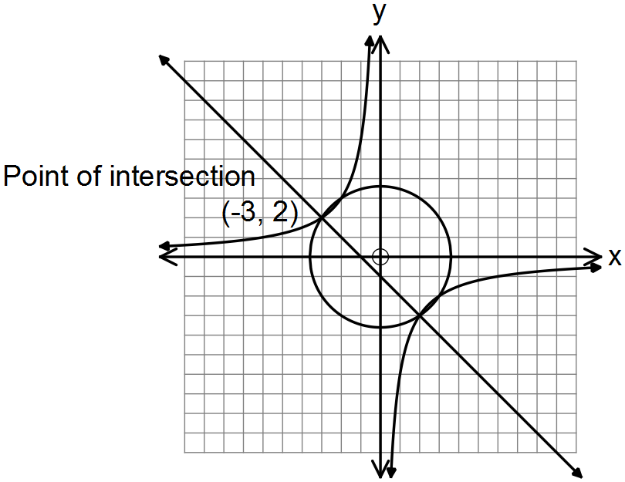

**(a)** State the equation for:

(i) 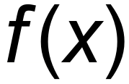, the circle with centre at the origin. (2 marks)

(ii) 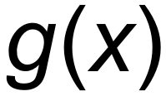, the hyperbola. (2 marks)

(iii) 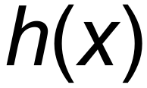, the straight line. (2 marks)

**(b)** Hence, solve the equation 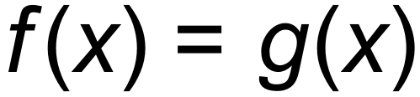. There are four solutions. (2 marks)

**(c)** The graph  undergoes the following transformation 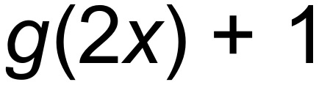.

(i) State the coordinates of the point (–3, 2) after this transformation has occurred.

(2 marks)

(ii) The graph  undergoes the same transformation namely 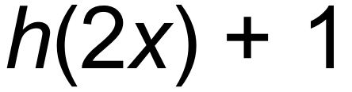. State the gradient of the transformed function. (1 mark)

**Question 12 (7 marks)**

**(a)** Consider the following sets of ordered pairs:

*f* = { (1,2), (2, 3), (3,4) } *h* = { ( 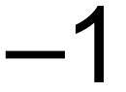, 4), (0, 3), (1,2) }

(i) Find *f* (2). (1 mark)

(ii) Find *a* such that *h* (*a*) = 3. (1 mark)

(iii)Find *t* such that *f* (*t*) = *h* (*t*). (1 mark)

**(b)** Compare the domain of 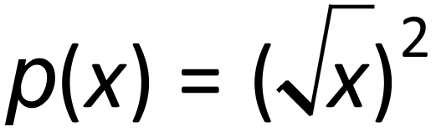 and 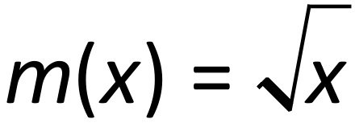. (2 marks)

**(c)** The function, 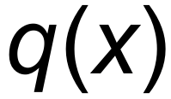 below, is a transformation of 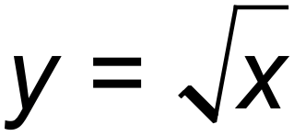.

State the equation of the function, 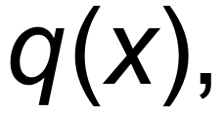 below. (2 marks)

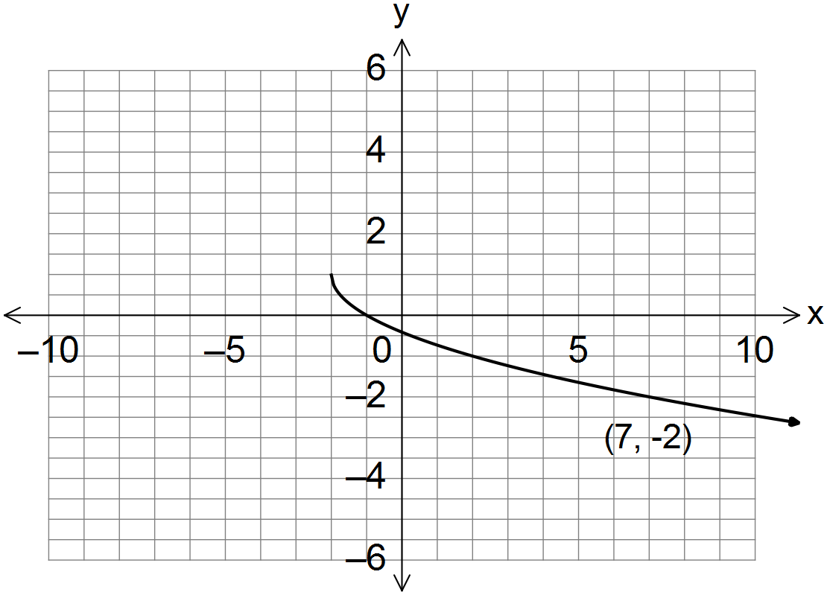

**Question 13 (6 marks)**

The following functions are shown below:

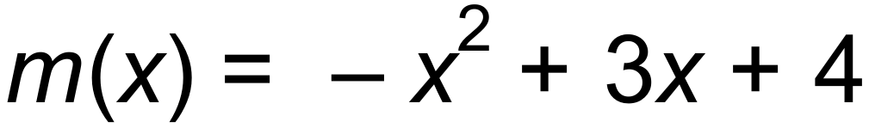 and 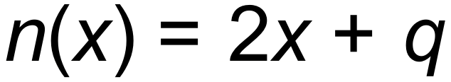, where *q* is a constant.

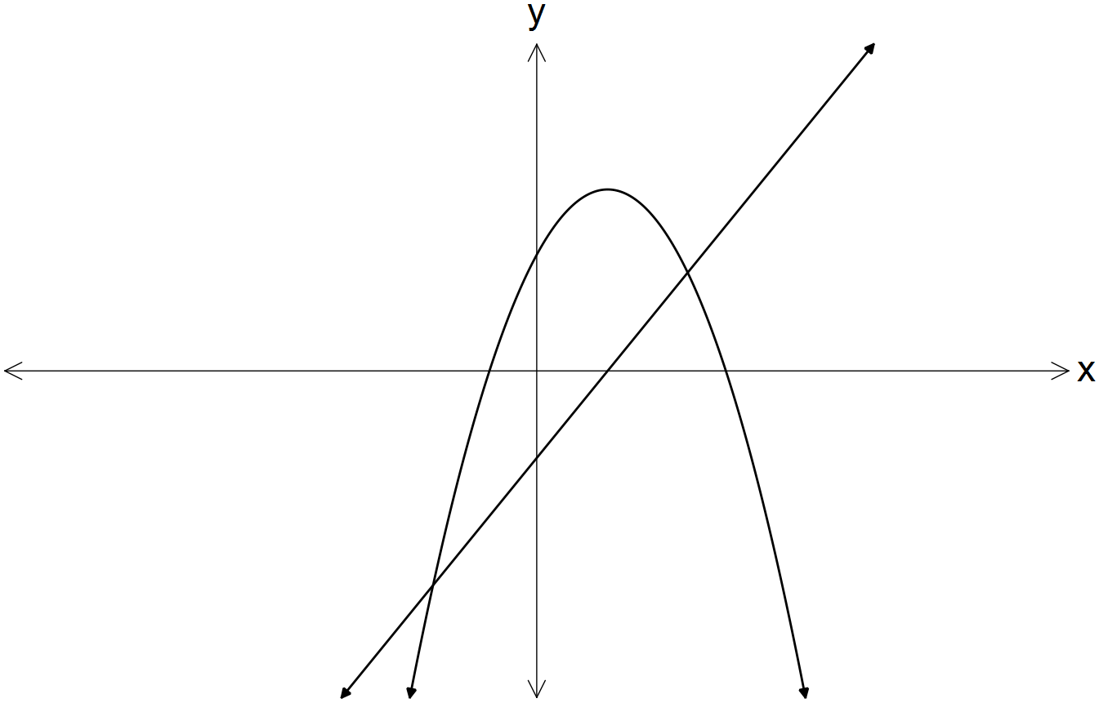

For what value(s) of *q* does the equation 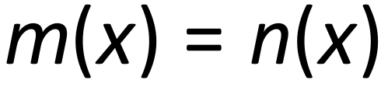 produce:

**(a)** one solution? (4 marks)

**(b)** no real solutions? (2 marks)

Question 14 (8 marks)

(a) The graph of $y=2x^{2}+bx+16$ has a line of symmetry with equation $x=3$.

(i) Determine the value of $b$. (2 marks)

(ii) Draw the graph of the parabola on the axes below. (3 marks)

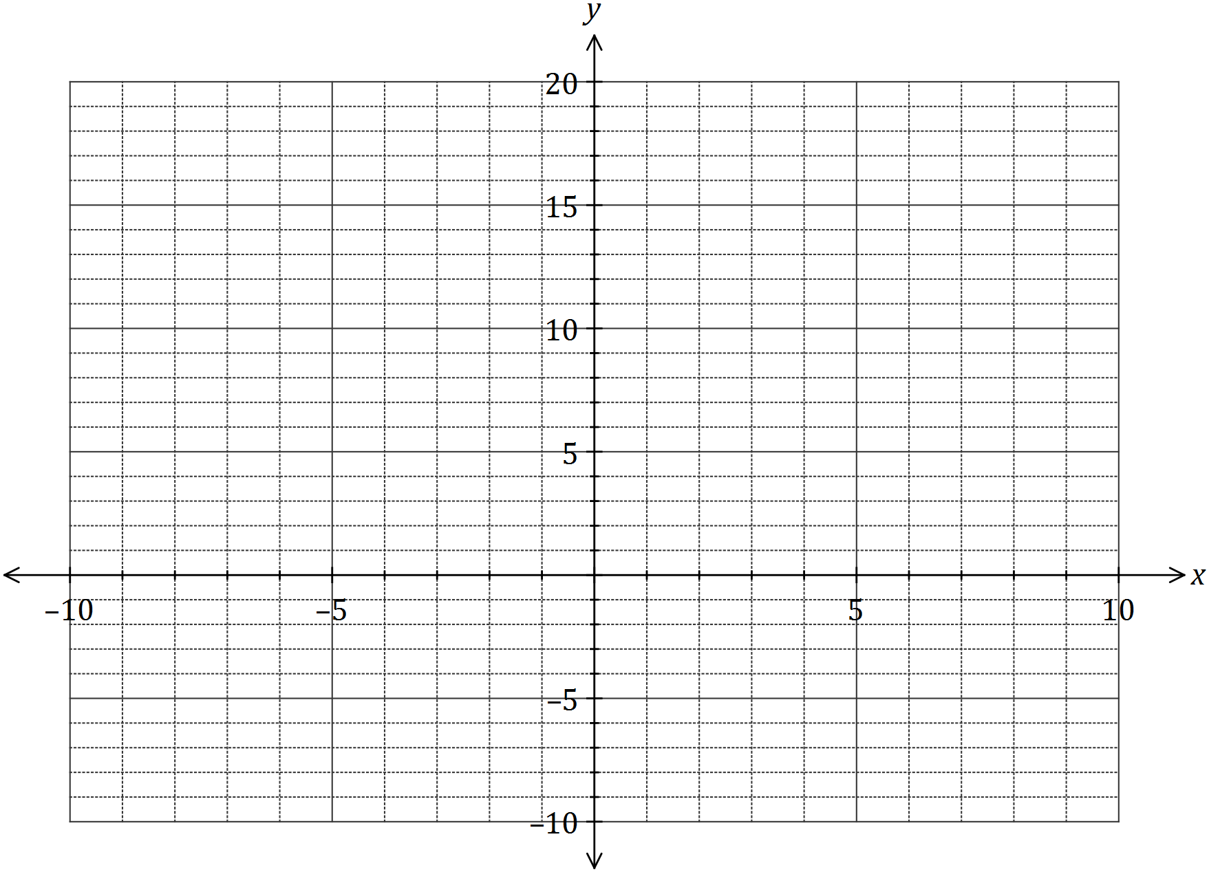

(b) One of the solutions to the equation $2x^{3}+21x^{2}+cx-495=0$ is $x=5$. Determine the value of $c$ and all other solutions. (3 marks)

**Question 15 (5 marks)**

**(a)** State the centre, *C*, and the radius, *r*, of the circle given by .

(2 marks)

**(b)** Write a possible equation, in terms of a, b and/or c, which are positive constants, for each graph shown below.

(3 marks)

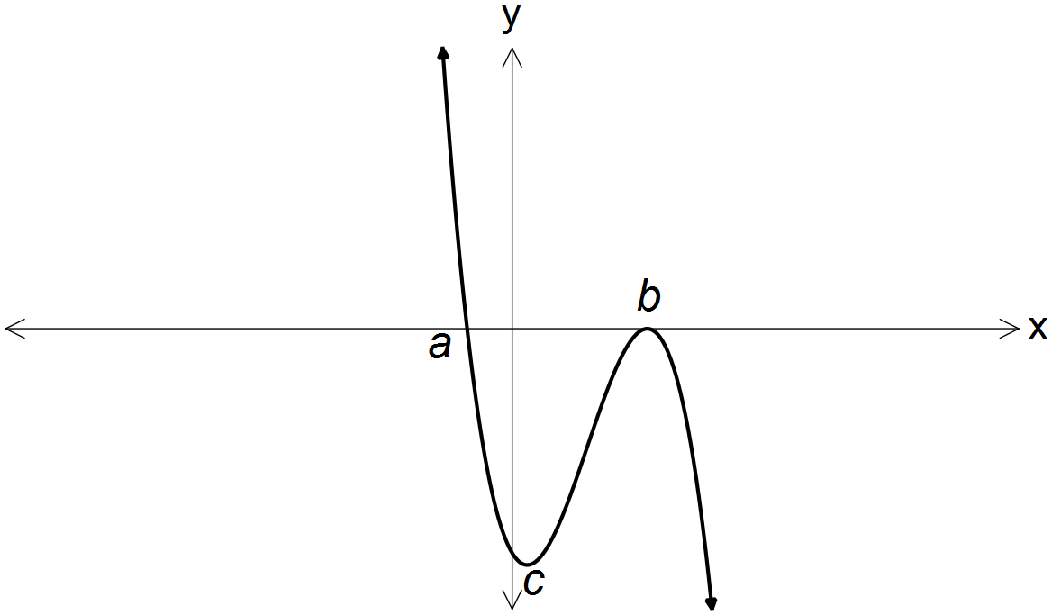 (i)

_________________________

(ii)

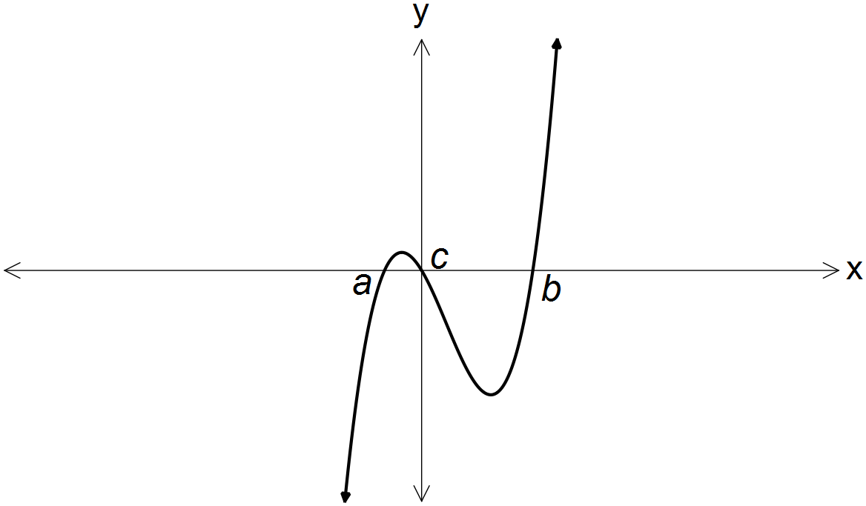

_________________________

(iii)

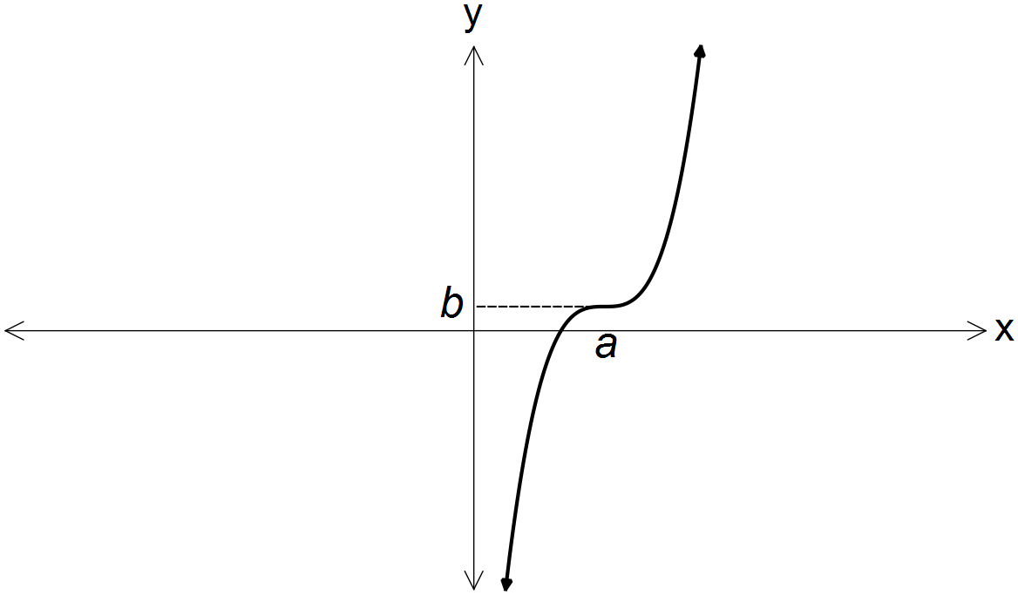

_________________________

Question 16 (8 marks)

The graph of the function is defined by $f\left(x\right)=$ $\frac{a}{x+b}$ is shown below.

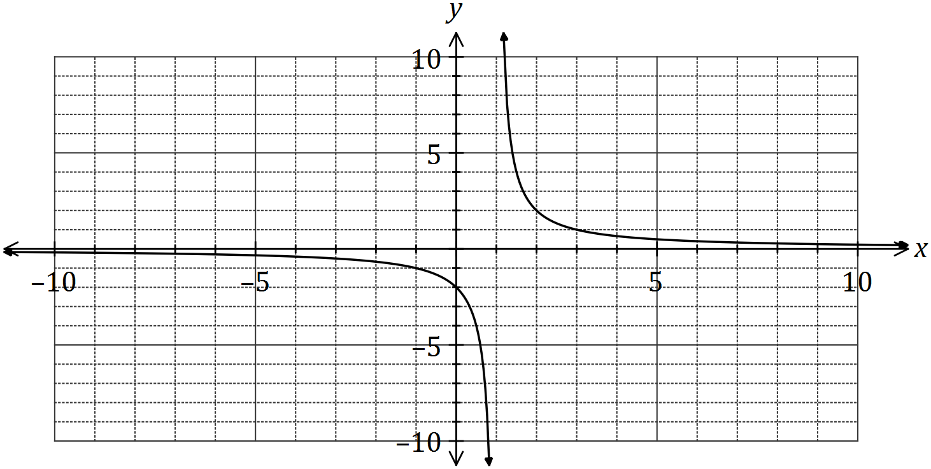

(a) Determine the values of $a$ and $b$. (2 marks)

(b) State the domain and range of $f\left(x\right)$. (2 marks)

(c) Determine the equations of the asymptotes of the graph of $y=f(2x)$. (2 marks)

(d) Describe the transformation required on the graph of $y=f(x)$ to obtain the graph of

(i) $y=f(x+8)$. (1 mark)

(ii) $y=\frac{1}{2}f(x)$. (1 mark)

Question 17 (8 marks)

Let 

1. Sketch the function on the axes below. (6 marks)

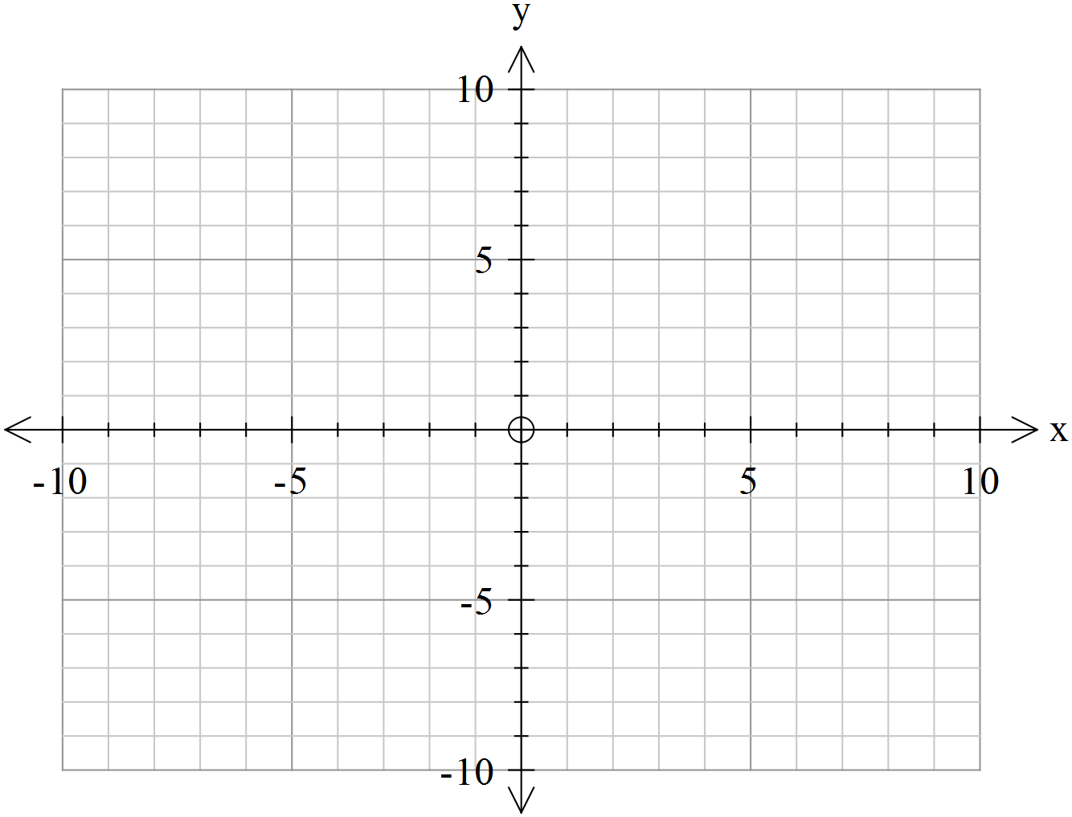

1. State the maximal(natural) domain and range. (2 marks)

Question 18 (8 marks)

1. A quantity z varies partly as directly proportional to x squared plus directly proportional to y cubed. For x=7 and y=11, z = 4189. For x=12 and y=5, z=951. Determine the value of z for x=9 and y=15. (4 marks)
2. If  determine the percentage change in w if x decreases by 30% and y increases by 20%. (4 marks)

Question 19 (8 marks)

1. Determine the quotient and remainder when  is divided by  (4 marks)
2. Determine the value of the constant  so that is a factor of  (4 marks)

End of exam!!!